Applying is dead in 2026. Follow these instead

Step1
Make a list of all the companies you want to get into. Use chatgpt for this. All the companies you have heard of. Even startups.

Step 2
Each weekend. Open linkedin. In the search bar type Talent Acquisition. Click on people in the search tab. In the filter, choose any 5 companies from your list.
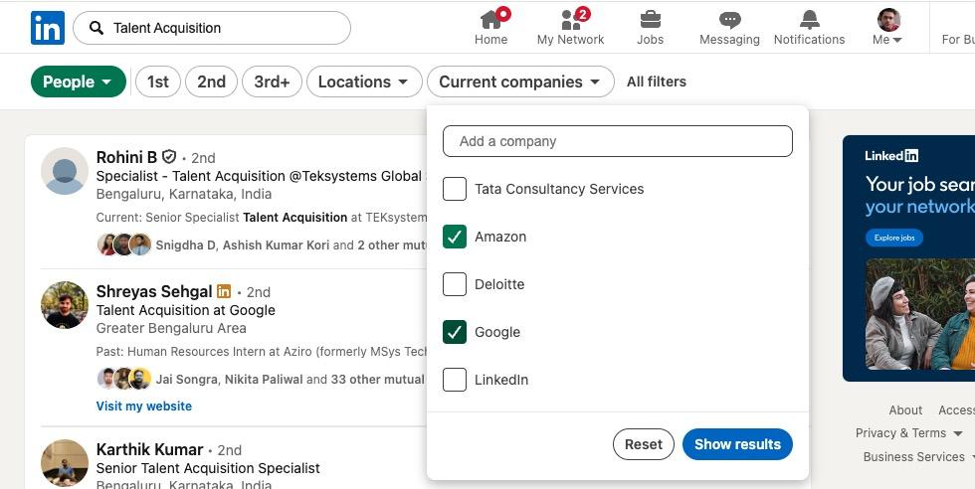

Step 3
If you have linkedin premium, you can also select Actively hiring from filters.
Right click on each profile and go to the profile page.
Click on Contact Info
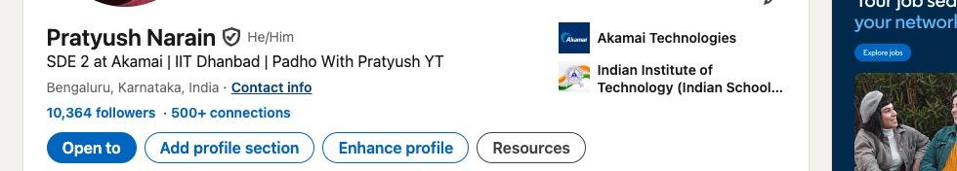

If you get the email there, copy it in a notepad.
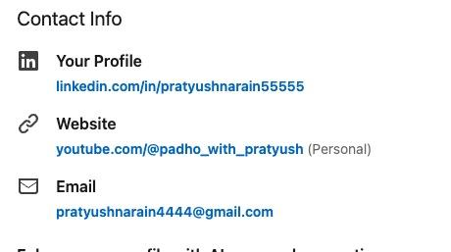

If not then use tools like hunter.io which give you the work email of these people. The free plan has enough credits.
Use similar tools like apollo.io if your free credit expire.
Here are top 10 tools which are free
https://docs.google.com/document/d/1-a_MfvRdR5rLG0mqB6NJJVTB8LtVFhDnrv62OI8IHWI/edit?usp=sharing

Step 4
Copy 100-150 emails of HR in the notepad. This will take 45 mins.

Step 5
Now open Gmail and type this email.
Hey,
I am currently working as a SDE 2 in {your company} . // if you are working
I am a graduate of {college name + year} . // if your are fresher

* I have solved 1500+ questions on platforms like LeetCode, Codechef, GFG
* I have exp in C/C++/Python and System Programming
* I have been involved in features like CPU Profiling (from scratch), Real time Congestion management and more.
* I have expertise in System design, developing scalable and performant systems and multi-threading.

Please let me know if there are roles at your company suitable for me. Attaching my resume for your reference.

Thanks and Regards,
Pratyush

Attach your resume and change the name and company. In the bullet points add your strengths like projects, dsa or any significant achievement.

In the To of the mail, give your own email.
In the BCC paste the entire list of HR so you wont have to send individual emails.

Repeat this process every weekend. It will not take more than an hour and will be helpful in getting interview calls.

